Taizhou University
School of Artificial Intelligence
Laboratory Report

班级 24计算机（留）（英） 学号 2462710034L 姓名 林樱

实验课程： Java EE Enterprise Development Technology
实验项目： Experiment 1: Introduction to Java Web Development

Experiment Date: 2026 年 3 月 18 日

Objectives
- To master Servlet programming.
- To be able to use Servlets to complete the development of a full Web application.

Experiment Content
- Develop a complete diary notebook application with the following functions:
  - Diary list: display all diary entries in reverse chronological order (date and diary title);
  - Create diary: record the creation time, IP address, title, main text, and other relevant information;
  - Edit diary content;
  - Delete diary entries;
  - Display diary details: show all the information recorded at the time of creation;
  - The application should have a certain degree of visual appeal.
- Development hints:
  - HTML templates can be implemented by using string replacement;
  - Diary content can be stored in files.

Experimental Procedures and Results
- Record the main operation steps, key code, and screenshots of the results;
- Briefly describe the difficulties encountered during this experiment and how you solved them;
- Please use a white background for screenshots instead of a black one, otherwise the printed version may look too dark.
- Development tools and kit
  - IDE: Intellij IDEA 2026.1
  - Server: Tomcat 10.1.53
  - Framework: Java Enterprise, Bootstrap 5, Javascript (native)
- Steps
  - Setup the project structure and environment with Tomcat and web framework:
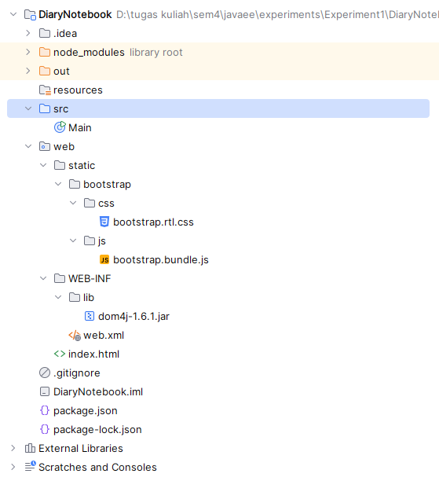
  - Install bootstrap and configure the file path inside the project structure
npm install bootstrap@5.3.8
  - Create the main page including search bar and pagination with the following HTML structures:
<!DOCTYPE html>
<html lang="en">
<head>
<meta charset="UTF-8">
<title>Diary App</title>
<link href="static/bootstrap/css/bootstrap.rtl.css" rel="stylesheet">
</head>
<body class="bg-light">

<div class="container mt-4">

<h3 class="mb-3 text-center">📔 Diary App</h3>

<!-- Top Controls -->
<div class="d-flex justify-content-between mb-3">
<button class="btn btn-primary" data-bs-toggle="modal" data-bs-target="#entryModal" onclick="openAddModal()">
+ Add New Diary
</button>

<input type="text" id="searchInput" class="form-control w-50" placeholder="Search..." onkeyup="renderTable()">
</div>

<!-- Table -->
<div class="card p-3">
<table class="table table-striped">
<thead>
<tr>
<th>Title</th>
<th>Date</th>
<th style="width: 220px;">Actions</th>
</tr>
</thead>
<tbody id="tableBody"></tbody>
</table>

<!-- Pagination -->
<nav>
<ul class="pagination justify-content-center" id="pagination"></ul>
</nav>
</div>
</div>
  - Create New Diary entry using Bootstrap modal
  - Create View modal showing added entry
  - Create Edit modal for editing the entry
  - Create Delete button for deleting the entry
<div class="modal fade" id="entryModal" tabindex="-1">
<div class="modal-dialog">
<div class="modal-content">

<div class="modal-header">
<h5 id="modalTitle" class="modal-title">Diary</h5>
</div>

<div class="modal-body">
<input type="hidden" id="entryId">

<p id="extraInfo" class="text-muted small"></p>
<input type="text" id="title" class="form-control mb-2" placeholder="Title">
<textarea id="content" class="form-control" rows="5" placeholder="Write here..."></textarea>
</div>

<div class="modal-footer">
<button class="btn btn-success" onclick="saveEntry()">Save</button>
<button class="btn btn-secondary" data-bs-dismiss="modal">Close</button>
</div>

</div>
</div>
</div>
  - Script for document object model:
<script src="static/bootstrap/js/bootstrap.bundle.js"></script>

<script>
let entries = JSON.parse(localStorage.getItem("entries")) || [];
let currentPage = 1;
let rowsPerPage = 5;

// SAVE (CREATE / UPDATE)
async function saveEntry() {
let id = document.getElementById("entryId").value;
let title = document.getElementById("title").value;
let content = document.getElementById("content").value;

if (!title || !content) {
alert("Please fill all fields!");
return;
}

if (id) {
// UPDATE (keep existing IP)
entries = entries.map(e => e.id == id ? { ...e, title, content } : e);
} else {
// FETCH IP ADDRESS
let ip = "Unknown";
try {
let res = await fetch("https://api.ipify.org?format=json");
let data = await res.json();
ip = data.ip;
} catch (error) {
console.log("IP fetch failed");
}

// CREATE
entries.unshift({
id: Date.now(),
title,
content,
date: new Date().toLocaleString(),
ip: ip
});
}

localStorage.setItem("entries", JSON.stringify(entries));
bootstrap.Modal.getInstance(document.getElementById("entryModal")).hide();

renderTable();
}

// OPEN ADD
function openAddModal() {
document.getElementById("modalTitle").innerText = "Add Diary";
document.getElementById("entryId").value = "";
document.getElementById("title").value = "";
document.getElementById("content").value = "";
}

// VIEW
function viewEntry(id) {
let entry = entries.find(e => e.id == id);

document.getElementById("modalTitle").innerText = "Diary Details";
document.getElementById("entryId").value = entry.id;

document.getElementById("title").value = entry.title;
document.getElementById("extraInfo").innerText =
"Created: " + entry.date + " | IP: " + entry.ip;
document.getElementById("content").value = entry.content;

// Add IP display
// alert("Created at: " + entry.date + "\nIP: " + entry.ip);

document.getElementById("title").disabled = true;
document.getElementById("content").disabled = true;

new bootstrap.Modal(document.getElementById("entryModal")).show();
}

// EDIT
function editEntry(id) {
let entry = entries.find(e => e.id == id);

document.getElementById("modalTitle").innerText = "Edit Diary";
document.getElementById("entryId").value = entry.id;
document.getElementById("title").value = entry.title;
document.getElementById("content").value = entry.content;

document.getElementById("title").disabled = false;
document.getElementById("content").disabled = false;

new bootstrap.Modal(document.getElementById("entryModal")).show();
}

// DELETE
function deleteEntry(id) {
if (confirm("Are you sure you want to delete this entry?")) {
entries = entries.filter(e => e.id != id);
localStorage.setItem("entries", JSON.stringify(entries));
renderTable();
}
}

// RENDER TABLE WITH SEARCH + PAGINATION
function renderTable() {
let table = document.getElementById("tableBody");
let search = document.getElementById("searchInput").value.toLowerCase();

let filtered = entries.filter(e =>
e.title.toLowerCase().includes(search) ||
e.content.toLowerCase().includes(search)
);

let start = (currentPage - 1) * rowsPerPage;
let paginated = filtered.slice(start, start + rowsPerPage);

table.innerHTML = "";

paginated.forEach(entry => {
table.innerHTML += `
<tr>
<td>${entry.title}</td>
<td>${entry.date}</td>
<td>
<button class="btn btn-success btn-sm" onclick="viewEntry(${entry.id})">View</button>
<button class="btn btn-warning btn-sm" onclick="editEntry(${entry.id})">Edit</button>
<button class="btn btn-danger btn-sm" onclick="deleteEntry(${entry.id})">Delete</button>
</td>
</tr>
`;
});

renderPagination(filtered.length);
}

// PAGINATION
function renderPagination(totalItems) {
let totalPages = Math.ceil(totalItems / rowsPerPage);
let pagination = document.getElementById("pagination");

pagination.innerHTML = "";

for (let i = 1; i <= totalPages; i++) {
pagination.innerHTML += `
<li class="page-item ${i === currentPage ? 'active' : ''}">
<button class="page-link" onclick="changePage(${i})">${i}</button>
</li>
`;
}
}

// CHANGE PAGE
function changePage(page) {
currentPage = page;
renderTable();
}

// INITIAL LOAD
renderTable();

document.getElementById("entryModal").addEventListener("hidden.bs.modal", function () {
document.getElementById("title").disabled = false;
document.getElementById("content").disabled = false;
});
</script>

</body>
</html>
- Results
  - Diary list:
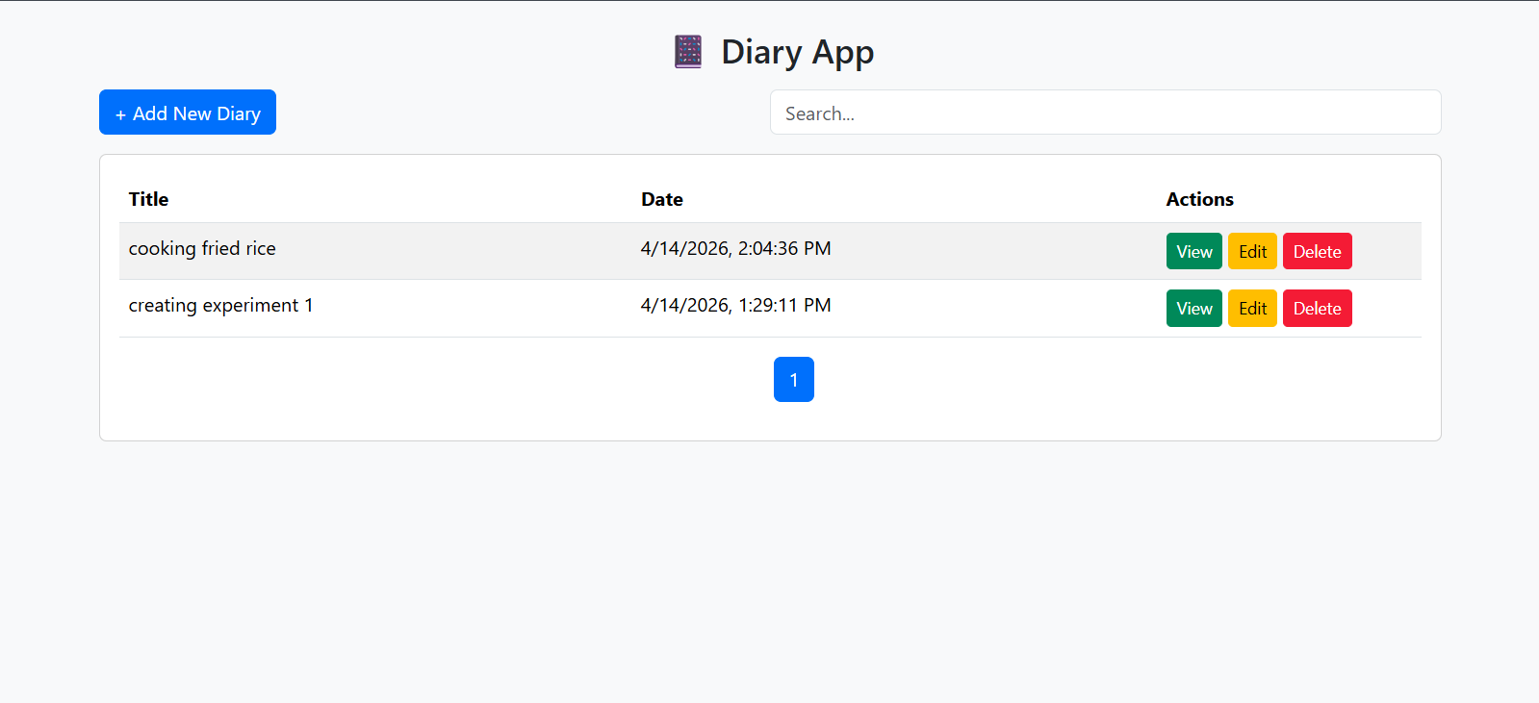
  - Add new diary:
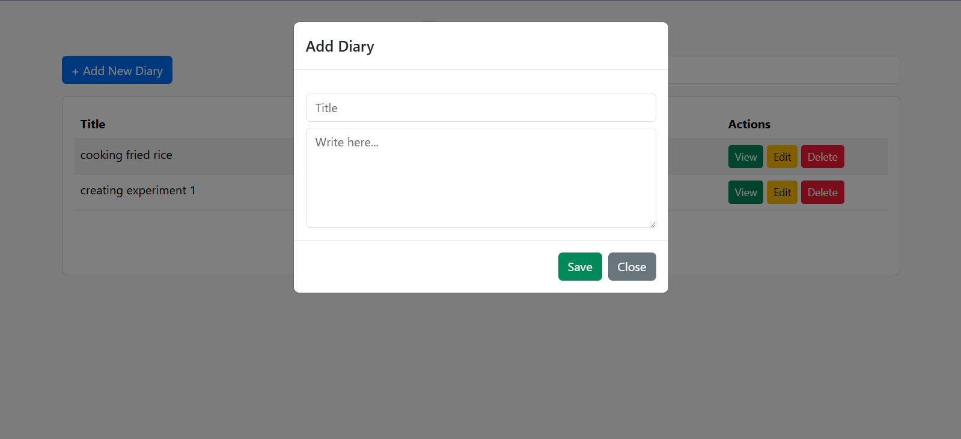
  - View diary:
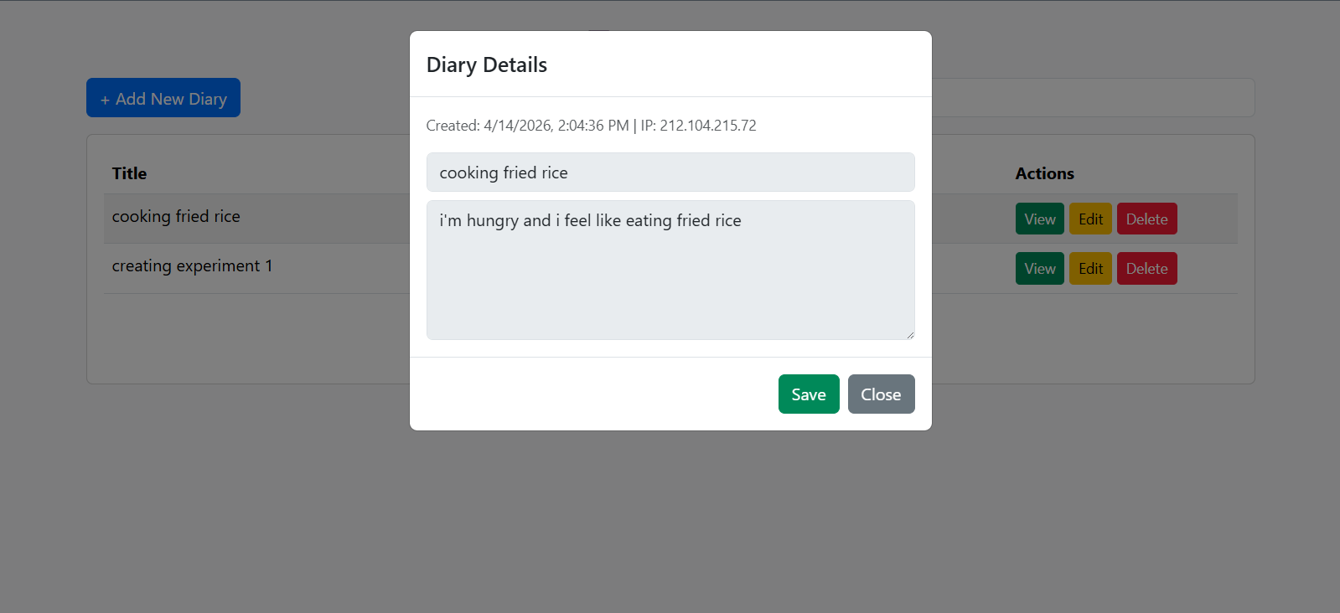
  - Edit diary:
Edit modal:
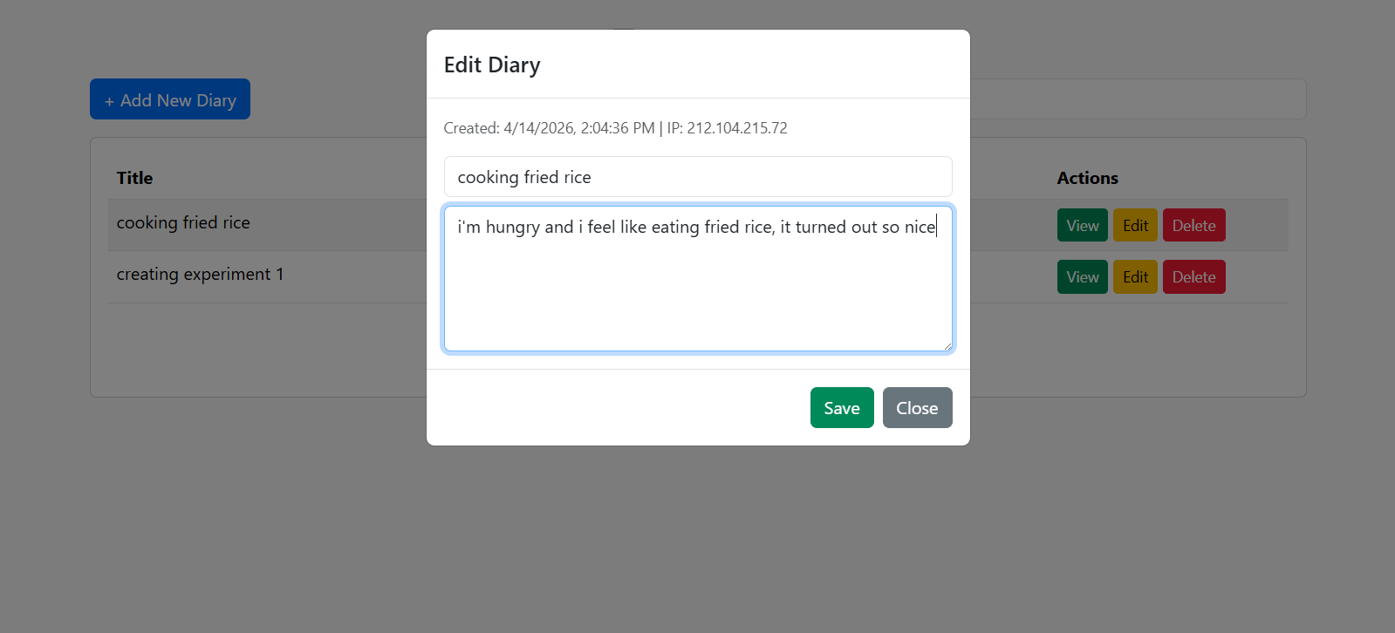
View modal after modification:
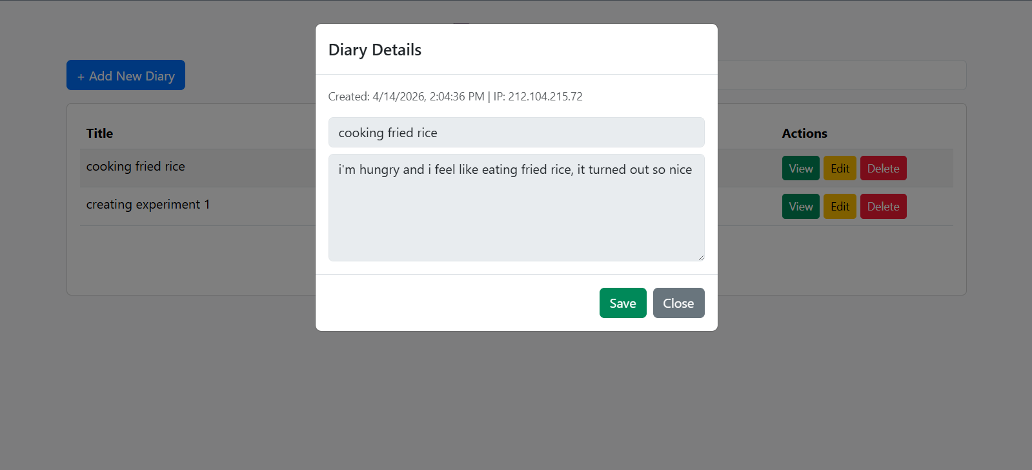
  - Delete diary:
Onclick delete button:
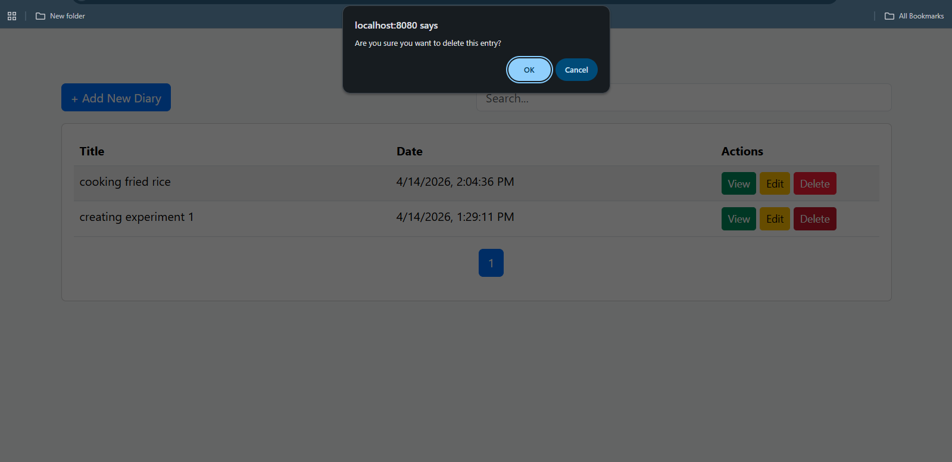
Diary list after deletion:
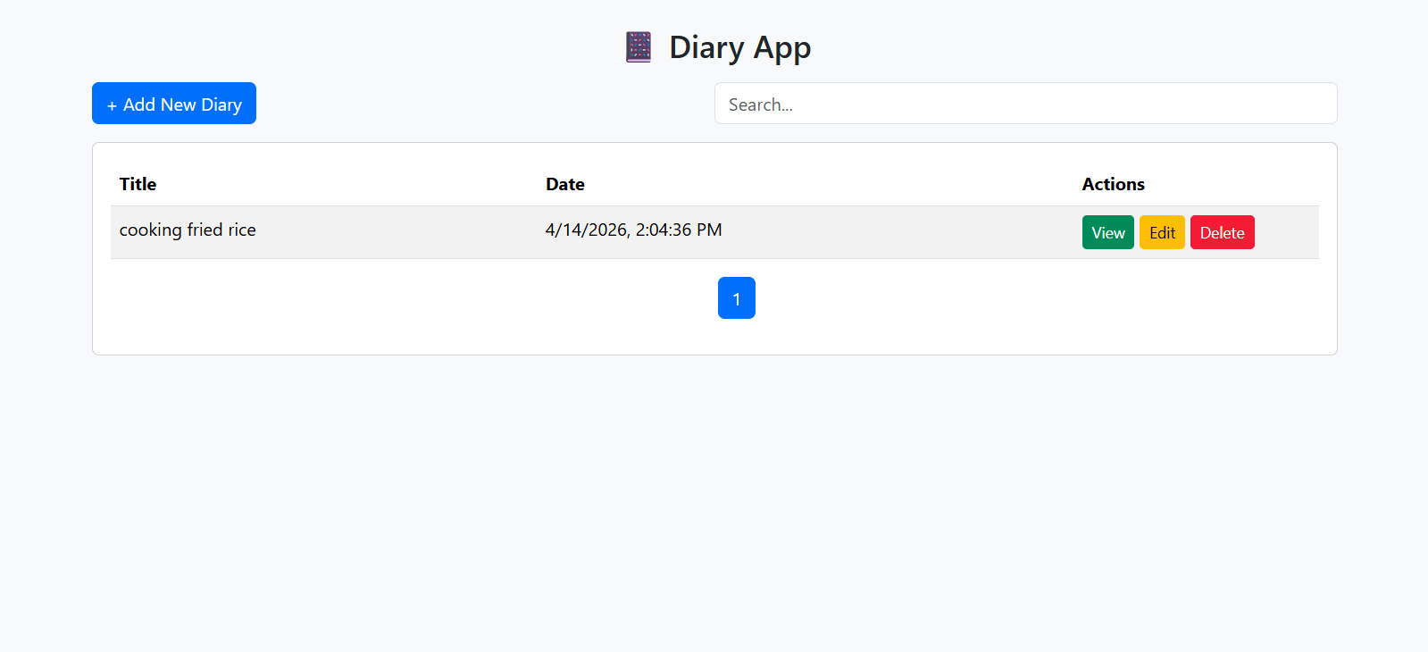
  - Search:
All diary list:
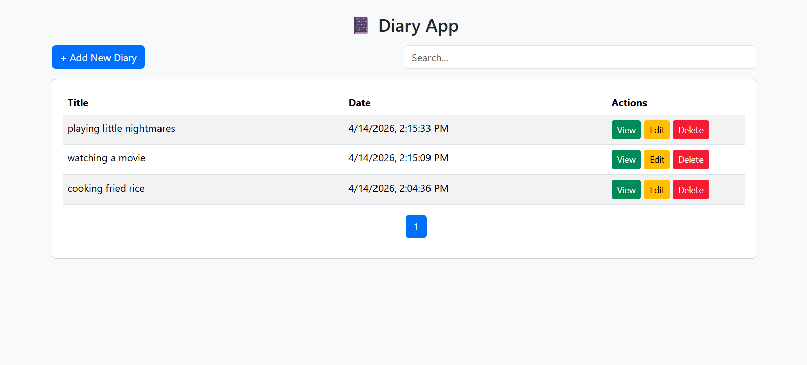Onsearch:
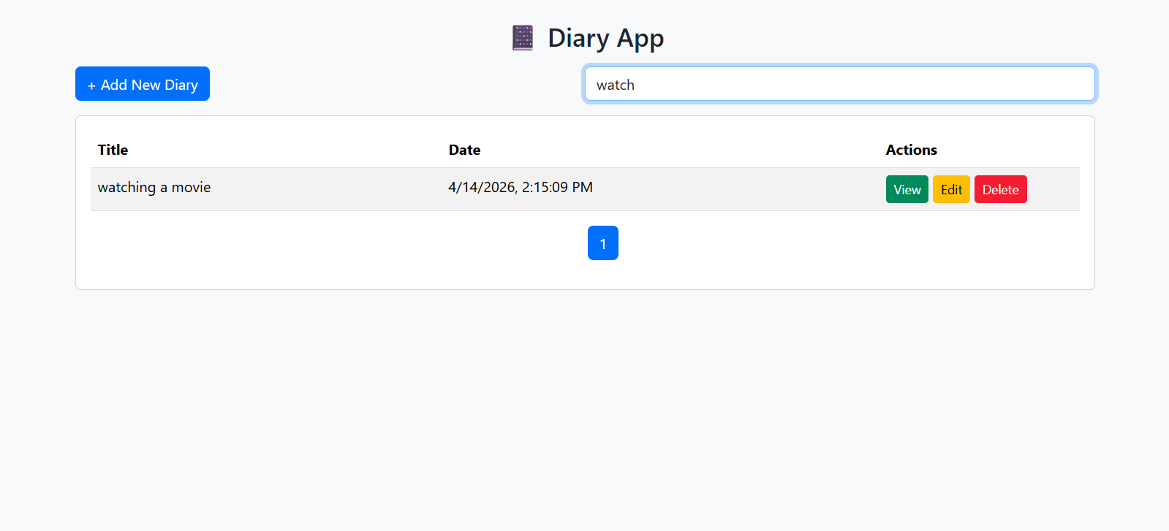
- Problems and Solutions
Bug views where the elements like buttons are not well aligned, fixed it by using correct Bootstrap alignment class attribute. Delete button didn’t work, fixed it by taking a look at the console in web browser and the response in the code there was a misspell for the ID.
- Reflections
Through this experiment, I have deepened my understanding about introduction to Java Web Application using Tomcat server. I also recall the usage of DOM (Document Object Model) Javascript which is one of the important things in developing website.

